Project 3.1 - Deploying Scalable Applications using ReplicaSets and Deployments

REPO :
For this I am using GKE 3 node cluster.
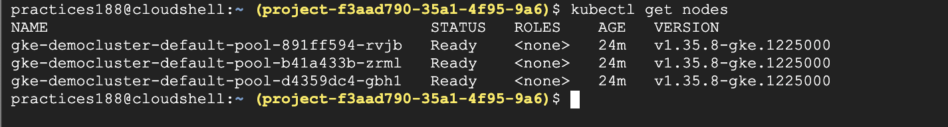

Task 1 - Prepare Application Container Image
Select or prepare a container image that will be deployed in the Kubernetes cluster. This image will be used to create multiple application Pods.
I have created this image: snehalshinde11/kubernetes-web-app
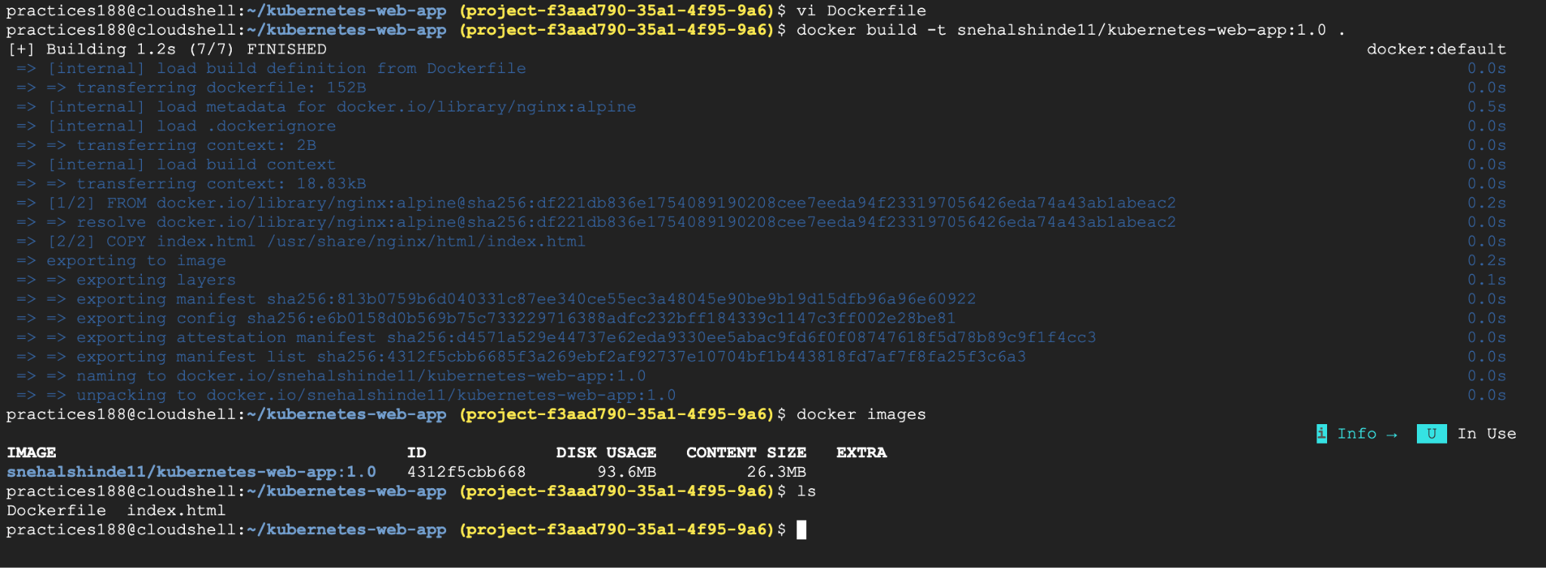
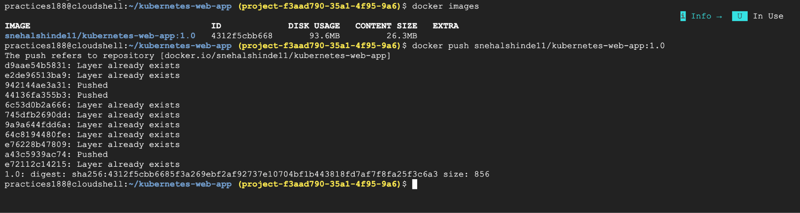

Task 2 - Create a Replicaset
Create a ReplicaSet configuration that defines the desired number of Pods running in the cluster. The ReplicaSet should automatically maintain the required number of replicas.

# vi replicaset.yaml →Create the replicaSet YAML
# kubectl apply --dry-run=client -f replicaset.yaml →Validate the YAML File
# kubectl apply -f replicaset.yaml →Create the ReplicaSet
#kubectl get replicaset →Check the ReplicaSet
# kubectl get rs →Check the ReplicaSet

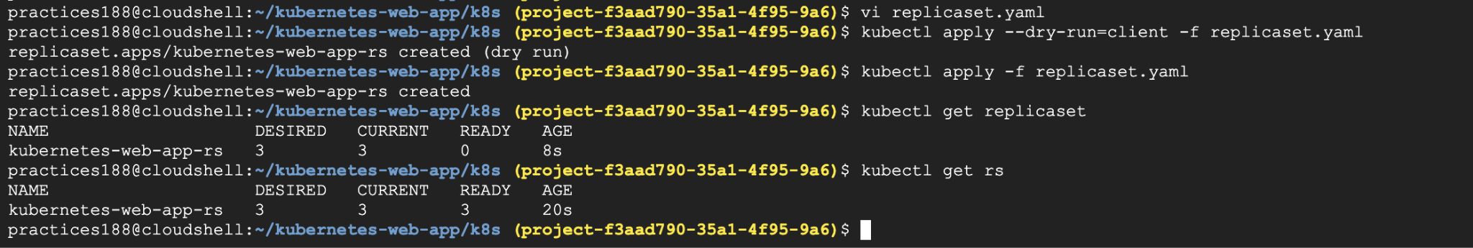
#kubectl get pods →Check the Pods
#kubectl get pods --show-labels →Check Pod labels
#kubectl describe rs kubernetes-web-app-rs →Get detailed ReplicaSet information
#kubectl get pods -o wide →Check the Pods with node information
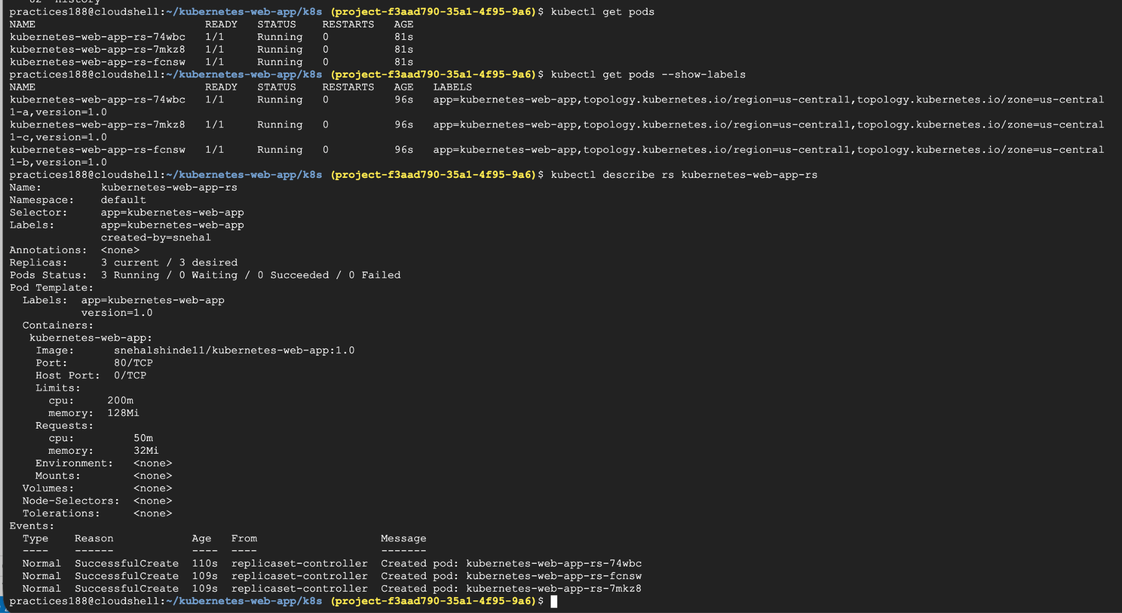

Verification :
Pick one pod : kubectl get pods
#kubectl exec -it <pod-name> -- nginx -T

You should see NGINX configuration.
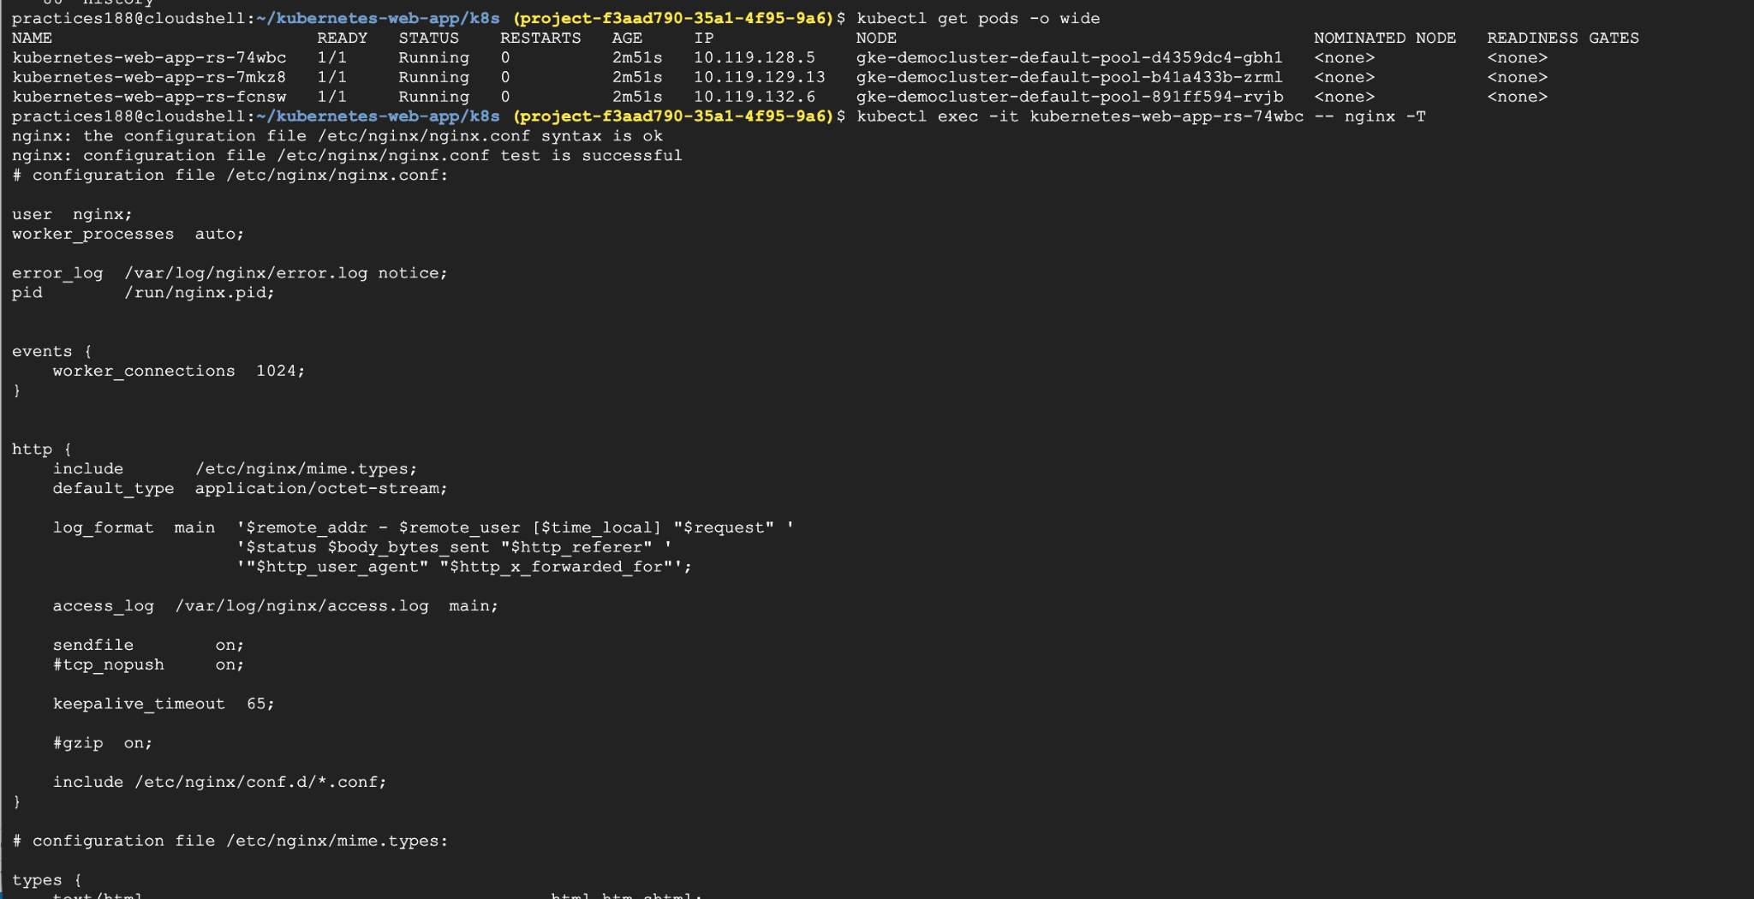

Or else :
#kubectl exec -it <pod-name> -- wget -qO- http://localhost

Task 3 - Verify ReplicaSet Behavior
Observe how the ReplicaSet maintains the number of running Pods. Simulate Pod failure and verify that Kubernetes automatically recreates the missing Pod.

For this First watch the Pods:#kubectl get pods -w
Keep that terminal open.Open another terminal and run:kubectl get pods
Pick one Pod:#kubectl delete pod
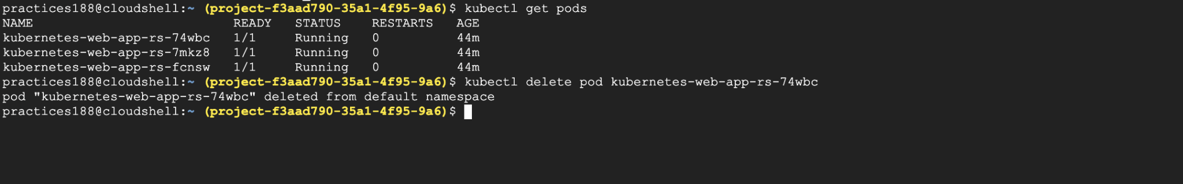
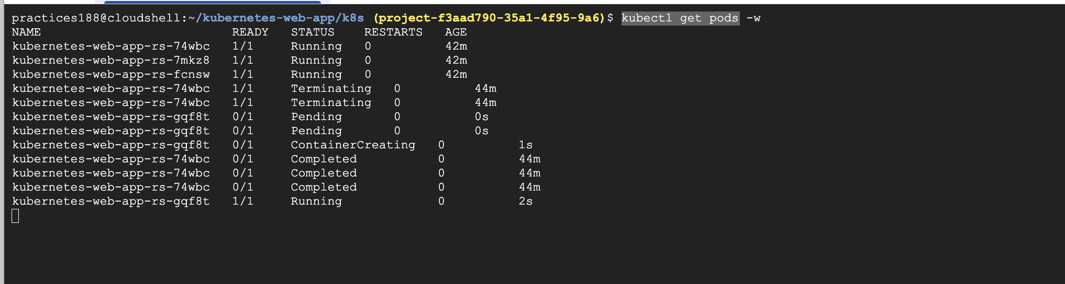

Eventually:3 Pods Running , That's Kubernetes self-healing.
The ReplicaSet noticed: Desired = 3 ,Current = 2
and automatically created another Pod: Desired = 3 ,Current = 3

Takeaway:
ReplicaSet maintains the desired number of Pods. When one Pod is manually deleted or fails, the ReplicaSet automatically creates a replacement Pod to bring the number of running Pods back to the desired count of three.

Task 4 - Create a Deployment
Create a Deployment resource that manages the application Pods. The Deployment should use a ReplicaSet to maintain application availability.
#cd ~/kubernetes-web-app/k8s

# vi deployment.yaml
#kubectl apply --dry-run=client -f deployment.yaml
→Validate
#kubectl apply -f deployment.yaml→create it
#kubectl get deployments →Check the deployment
#kubectl get deployment kubernetes-web-app →Check the deployment
#kubectl get rs →Check the repllicaSet deployed
#kubectl get deployment
#kubectl get rs
#kubectl get pods --show-labels
#kubectl describe deployment kubernetes-web-app →Check the deployment in details for NewReplicaSet: kubernetes-web-app-rs (3/3 replicas created)

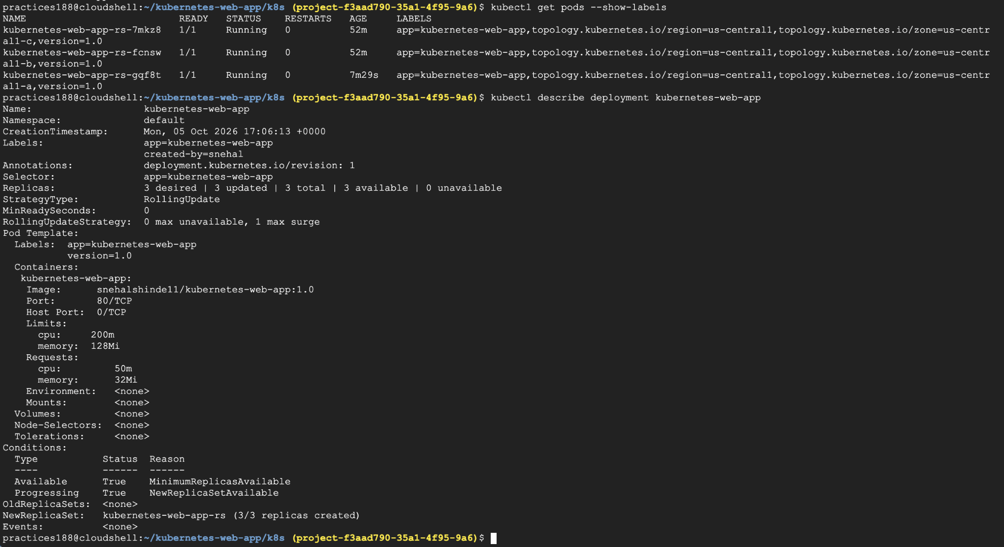

Task 5 - Scale the Application
Increase the number of application replicas using the Deployment configuration.
Verify that additional Pods are created automatically.
For this lets Scale the application: 3 → 5 Pods
First check #kubectl get deployment
#kubectl get pods
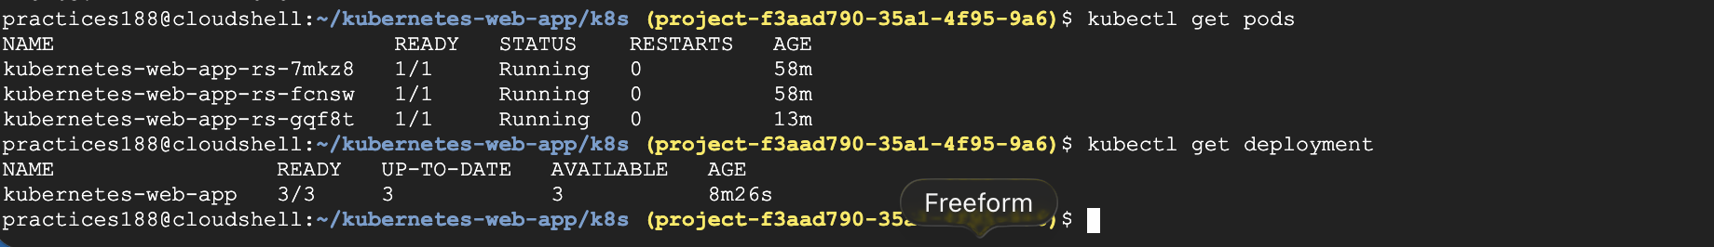

In other terminal scale the deployment using :
#kubectl scale deployment kubernetes-web-app --replicas=5
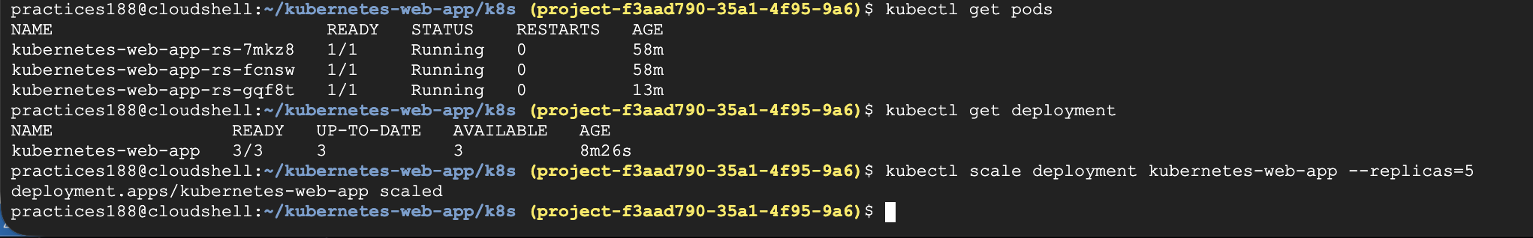
In One terminal watch the pods :
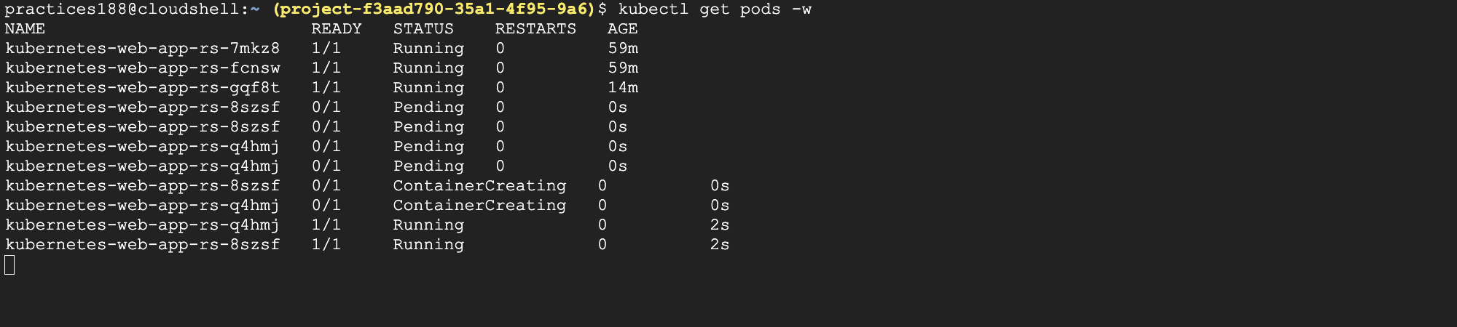

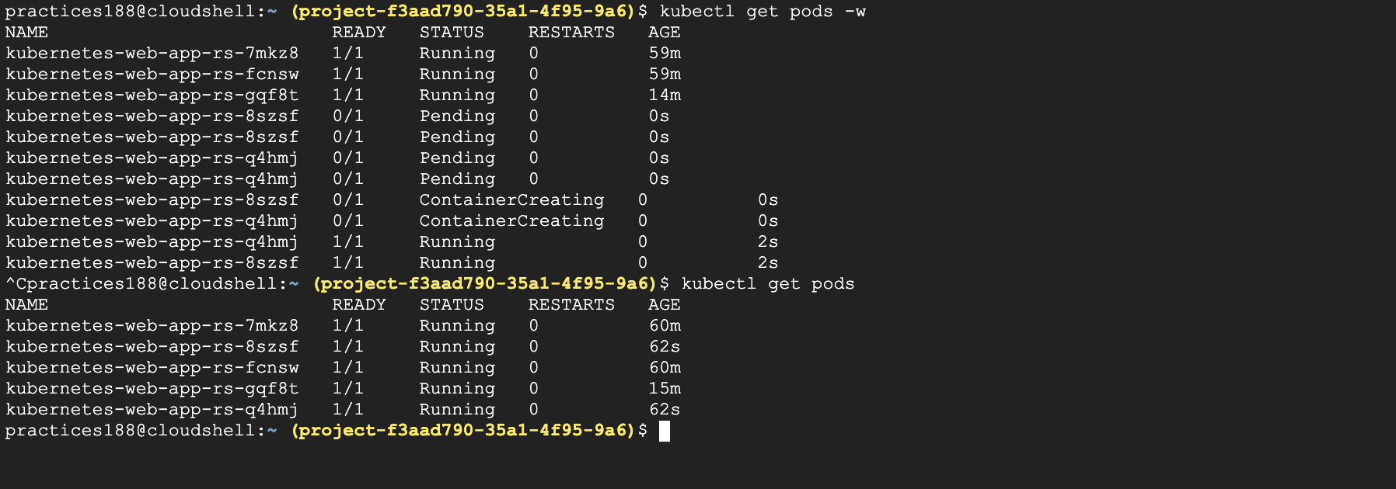

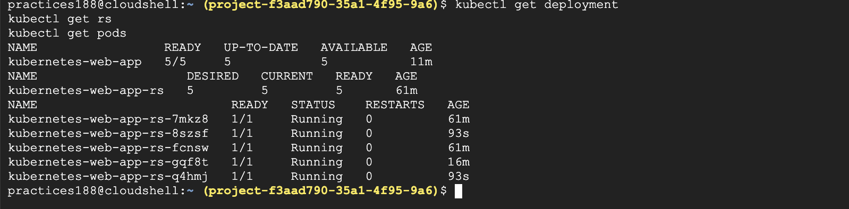

Task 6 - Perform Rolling Update
Update the application version using the Deployment. Observe how Kubernetes gradually replaces old Pods with new ones without downtime.
Updating the application version without taking the application down.

Create the v2 application :
#cd ~/kubernetes-web-app
#ls
#cp index.html index-v1-backup.html → Take backup of existing index.html for version 1
# vi index.html →modify the index.html for version 2
# ls
#docker build -t snehalshinde11/kubernetes-web-app:2.0 .
→Build the image for 2.0 tag

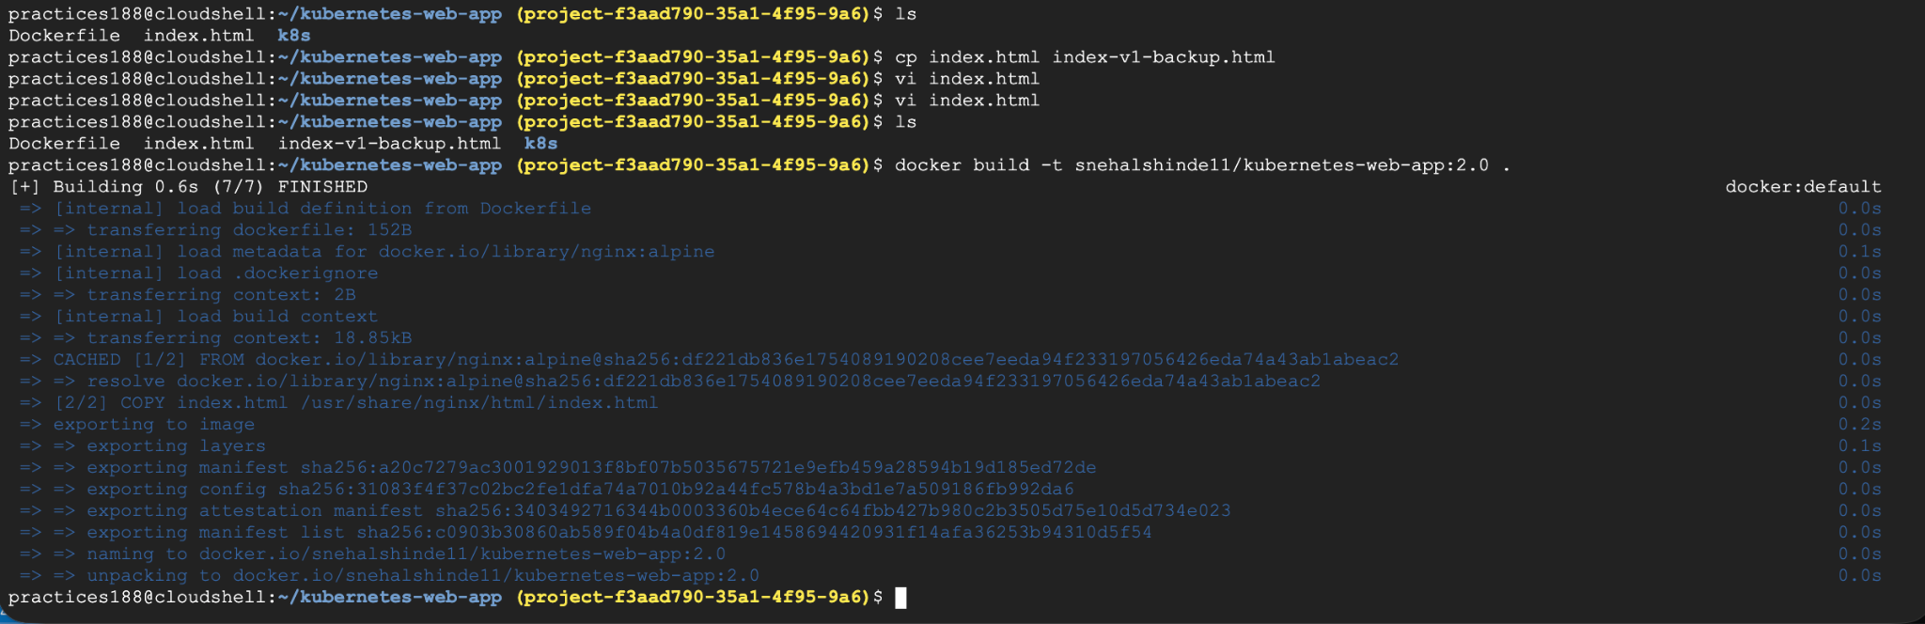
Push to dockerhub repo.

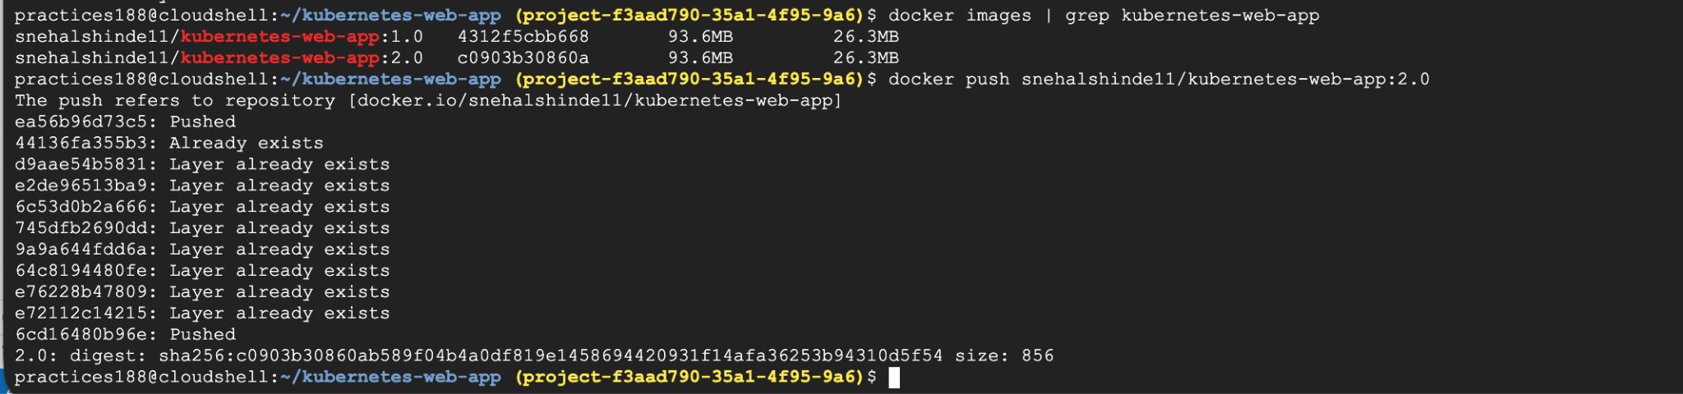

Now lets Perform the Rolling Update :

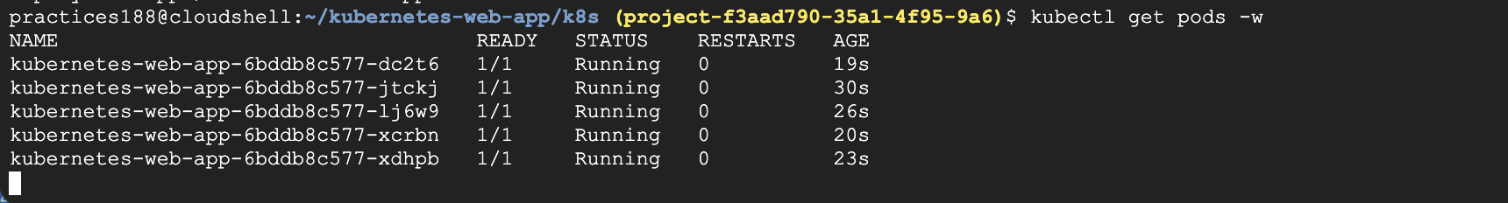
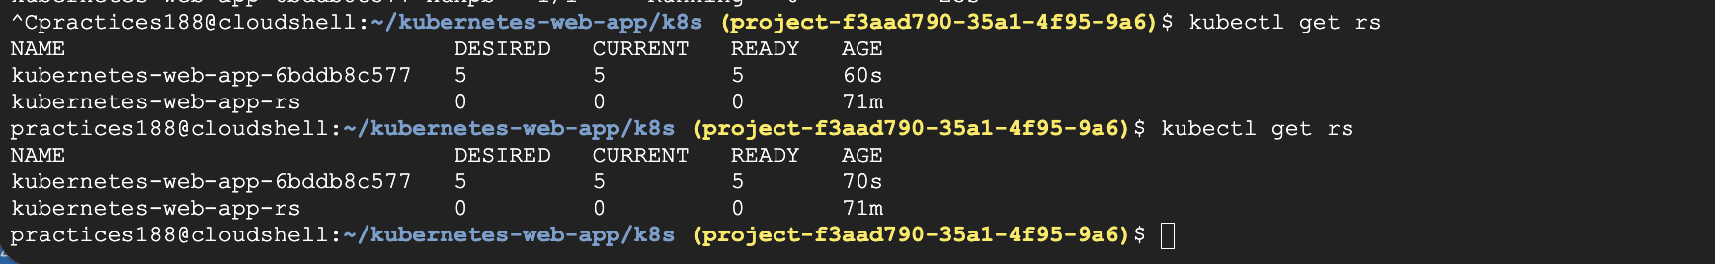

#kubectl get pods -w
# kubectl get rs
# kubectl get pods -o wide
#kubectl describe deployment kubernetes-web-app | grep "Image:"
→check the deployment with new image
#kubectl rollout history deployment/kubernetes-web-app
→ check the rollout history.

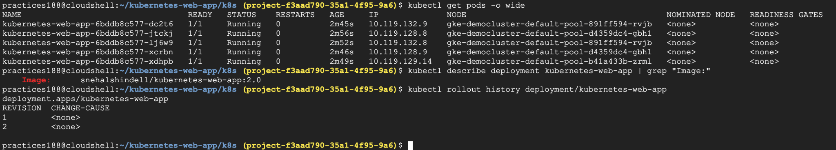

As we are using the GKE cluster so lets
First confirm your Pods are running: #kubectl get pods
Now run: #kubectl port-forward deployment/kubernetes-web-app 8080:80 --address=0.0.0.0
Keep this terminal running.
Open it in the browser
In Google Cloud Shell, click:
Web Preview → Preview on port 8080

Dashboard created for version two Snehal Shinde. → that’s the change in image 2.

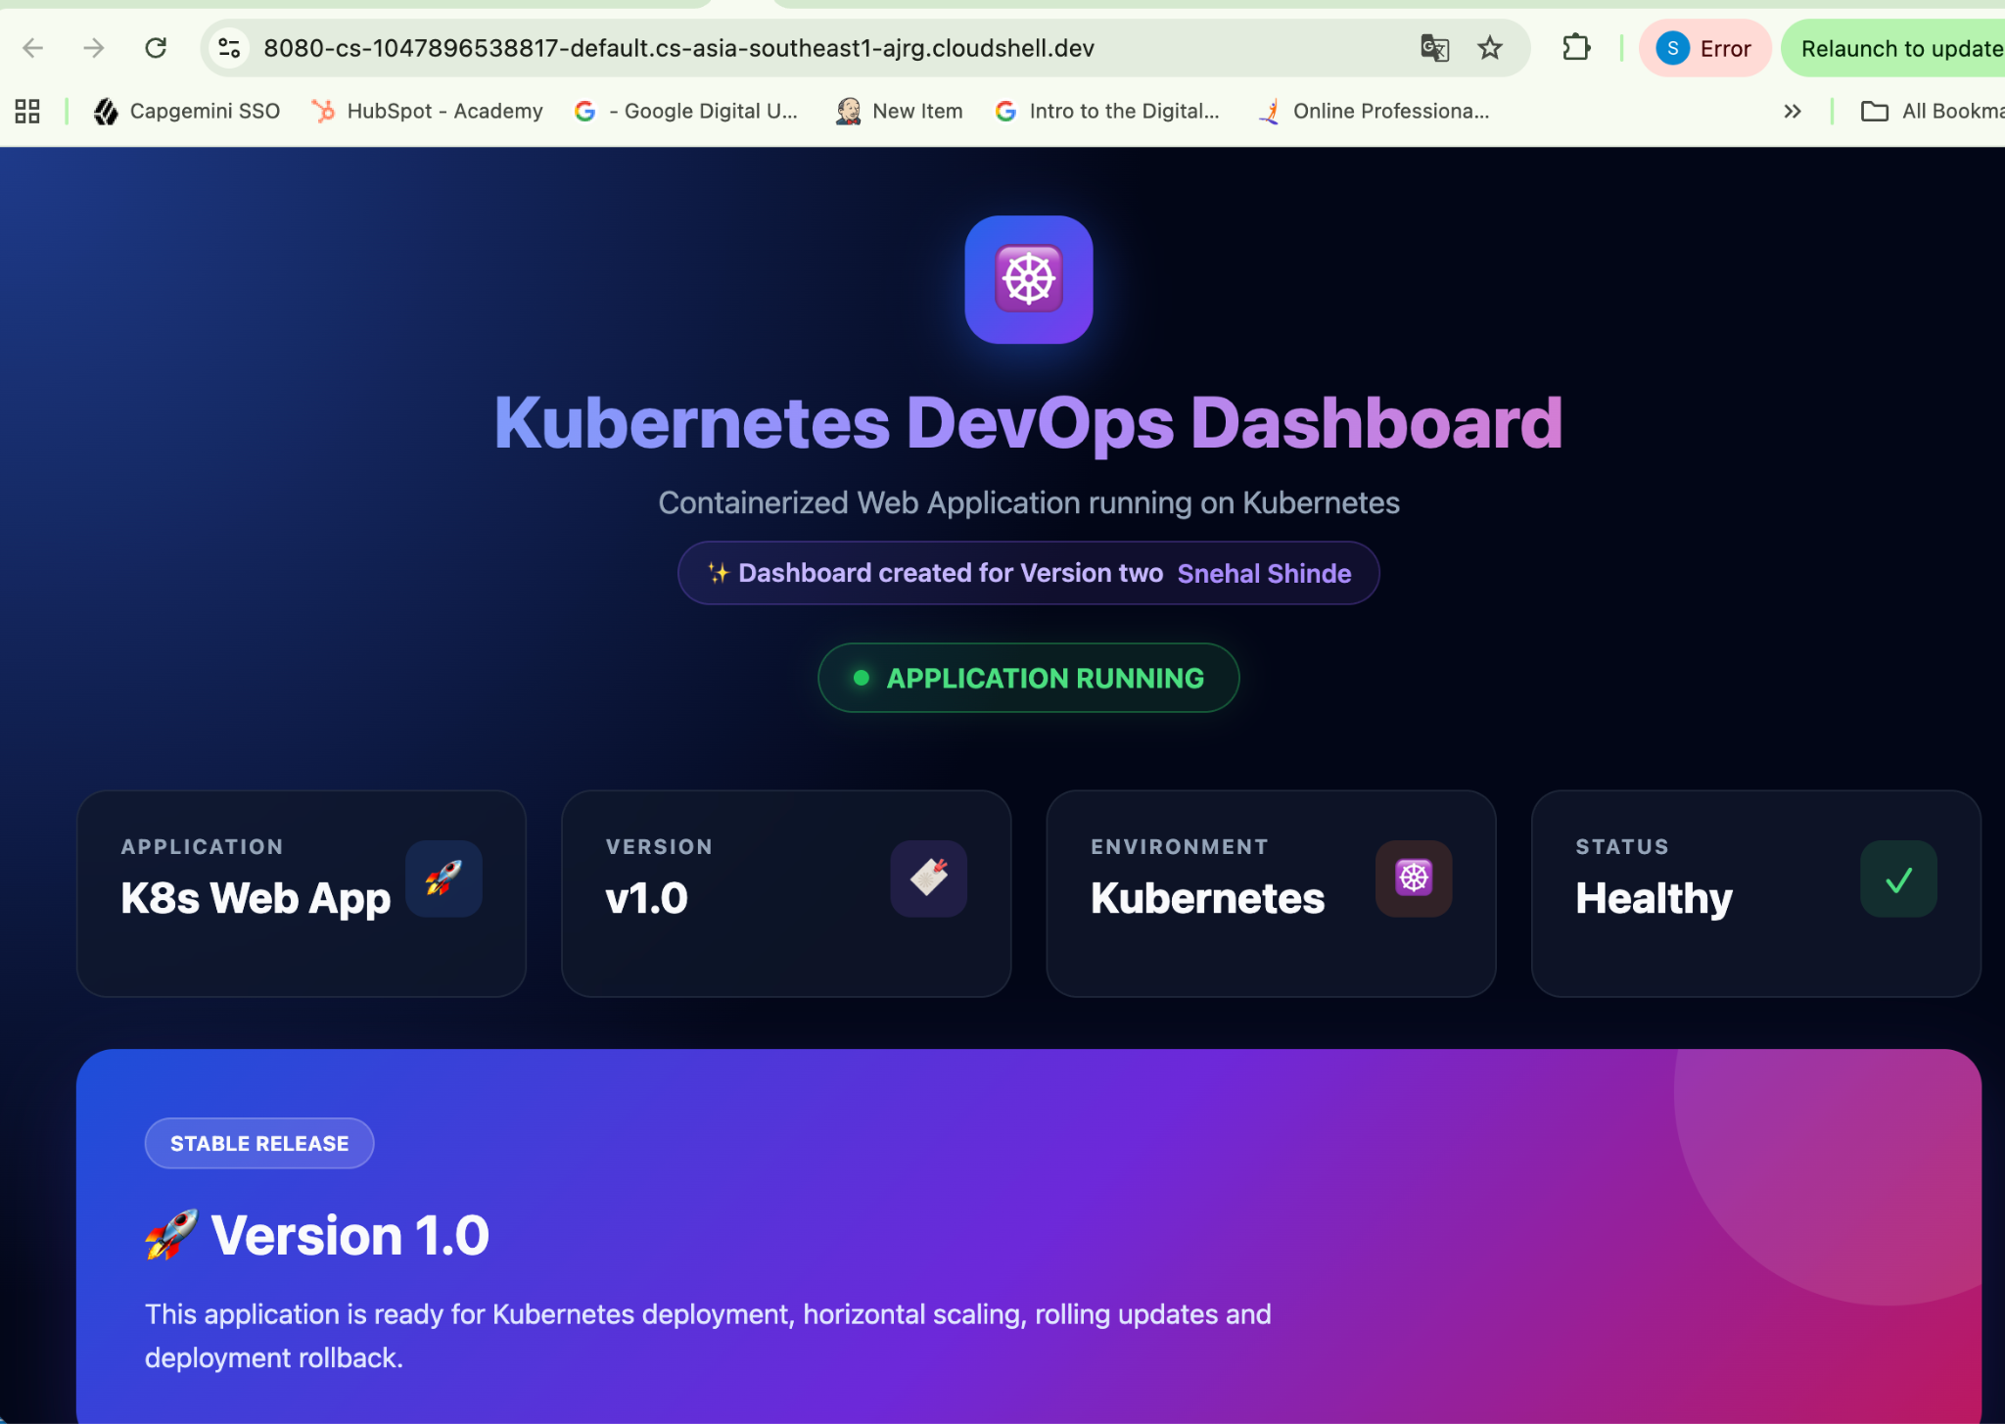

Task 7 - Rollback Deployment
Simulate a failed deployment and perform a rollback to the previous stable version.
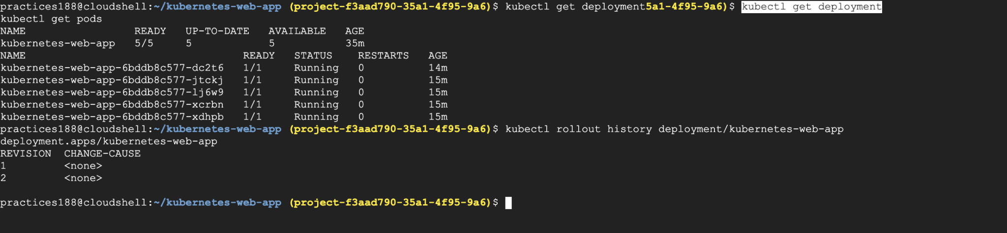

Simulate the failed deployment : for this We can use a nonexistent 3.0 image:

#kubectl set image deployment/kubernetes-web-app \
kubernetes-web-app=snehalshinde11/kubernetes-web-app:3.0

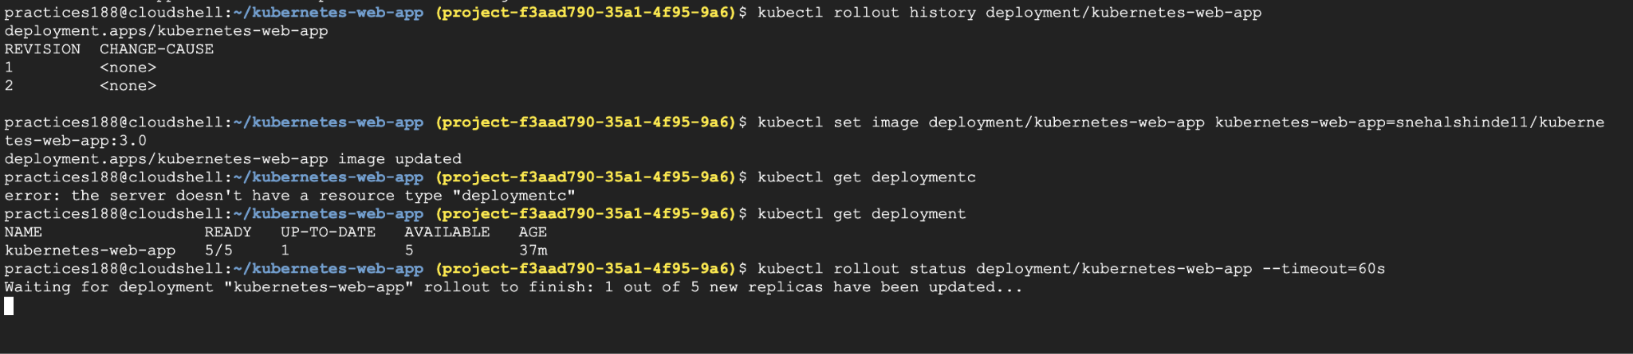
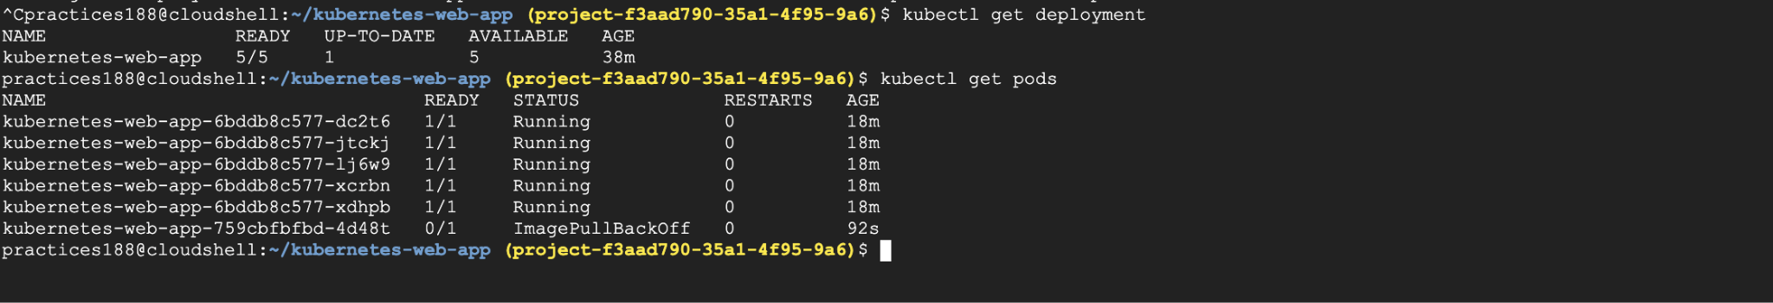

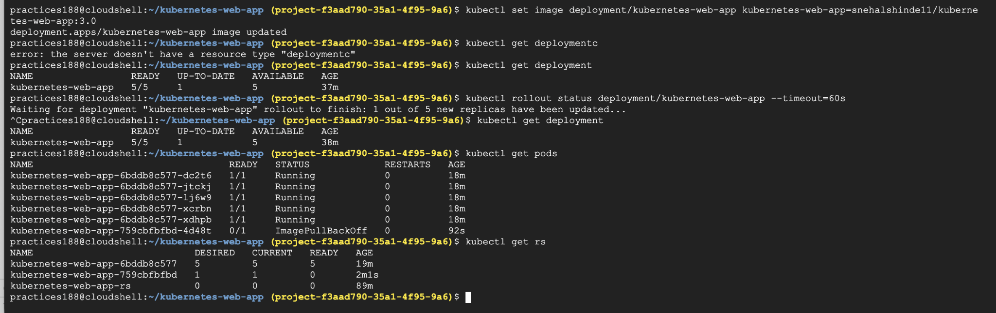

Now rollout to the previous version :
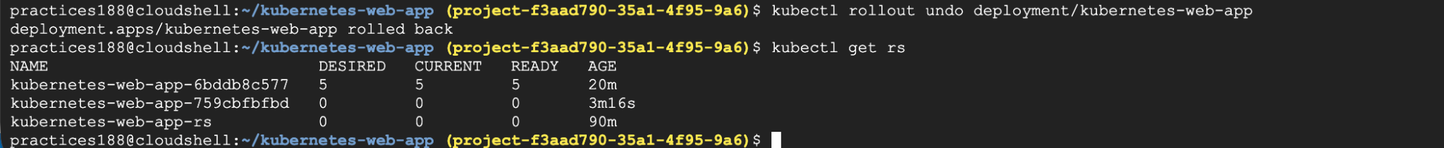

Verify that the application returns to the previous state.
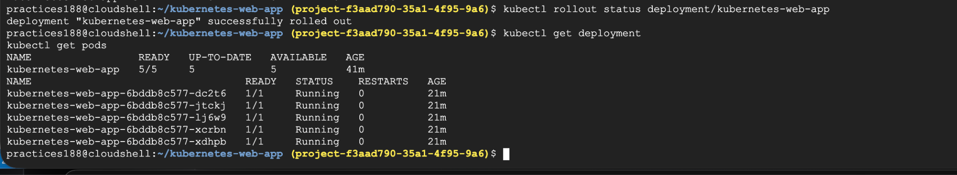

Now lets rollback to version 1:
#kubectl set image deployment/kubernetes-web-app \
kubernetes-web-app=snehalshinde11/kubernetes-web-app:1.0
#kubectl rollout status deployment/kubernetes-web-app
In another terminal : #kubectl get rs

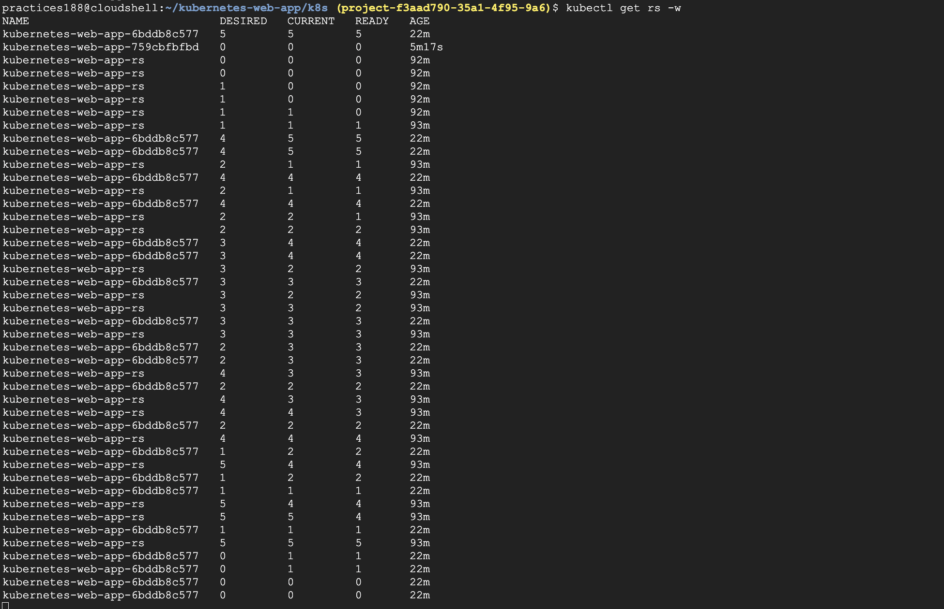

Check on web preview :
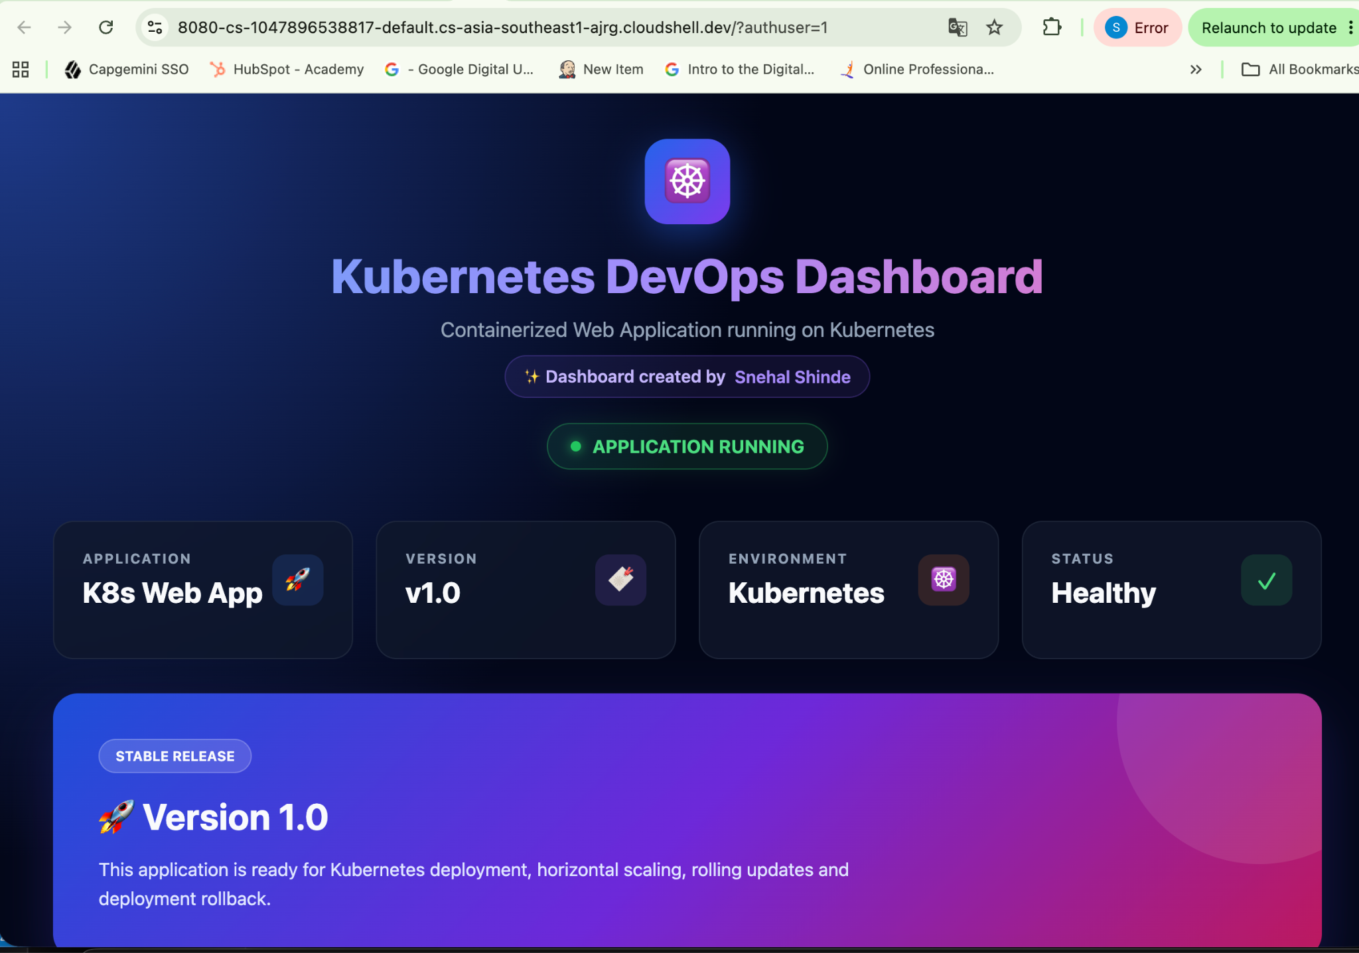
Without Version two mentioned .

Expected Outcome
At the end of this project:
- ﻿﻿ReplicaSets maintain the desired number of Pods.
- ﻿﻿Deployments manage application lifecycle and updates.
- ﻿﻿Applications scale horizontally with multiple replicas.
- ﻿﻿Rolling updates allow new versions to be deployed without downtime.

Deliverables
Learners should submit:
- ﻿﻿YAML configuration for ReplicaSet
- ﻿﻿YAML configuration for Deployment
- ﻿﻿Screenshot showing multiple running Pods
- ﻿﻿Screenshot showing scaled application replicas
- ﻿﻿Screenshot showing rolling update behavior

Beyond the Basics - Elevate Exercise
Enhance the deployment by adding:
- ﻿﻿Expose the application using a Kubernetes Service
#vi service.yaml
#kubectl apply -f service.yaml
# kubectl get service
#kubectl get endpoints kubernetes-web-app-service

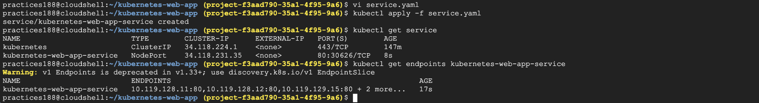

- ﻿﻿Enable auto-scaling using Horizontal Pod Autoscaler
HPA CPU utilization is calculated against the requested CPU.
First check whether Metrics Server is available:kubectl top pods
If you get Pod CPU/memory numbers, You are ready.
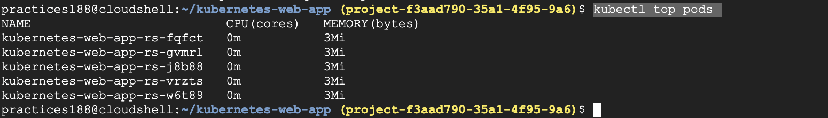

# vi hpa.yaml
#kubectl apply -f hpa.yaml
#kubectl get hpa
#kubectl describe hpa kubernetes-web-app-hpa

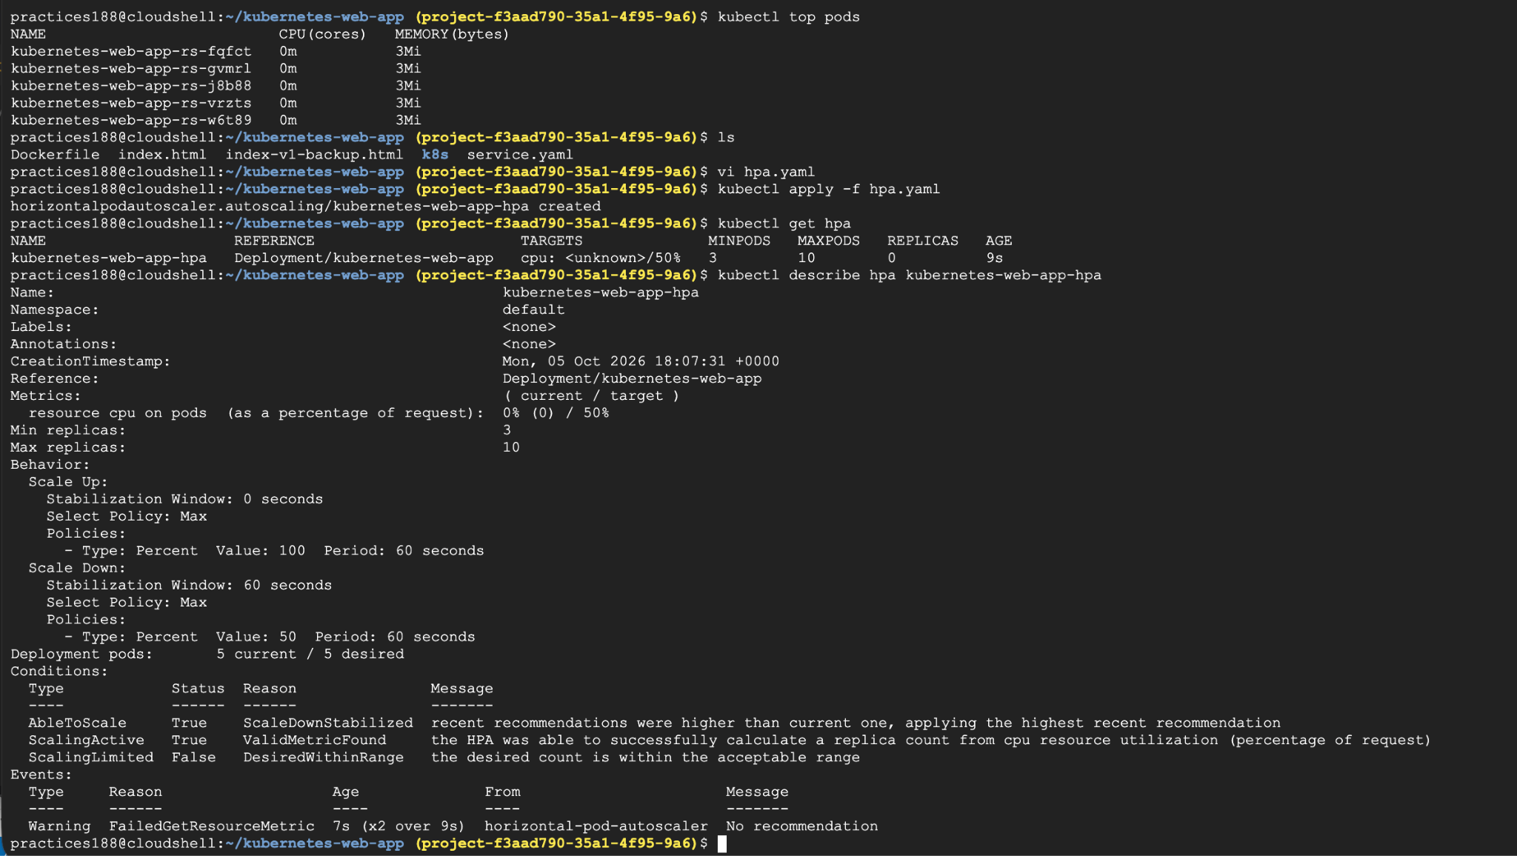

- ﻿﻿Add resource limits for Pods
Current Deployment already has them:
resources:
requests:
cpu: "50m"
memory: "32Mi"
limits:
cpu: "200m"
memory: "128Mi"

- ﻿﻿Monitor Pods using kubectl and logs
#kubectl get pods
# kubectl get pods -o wide
# kubectl get pods -w
#kubectl top pods
# kubectl top nodes

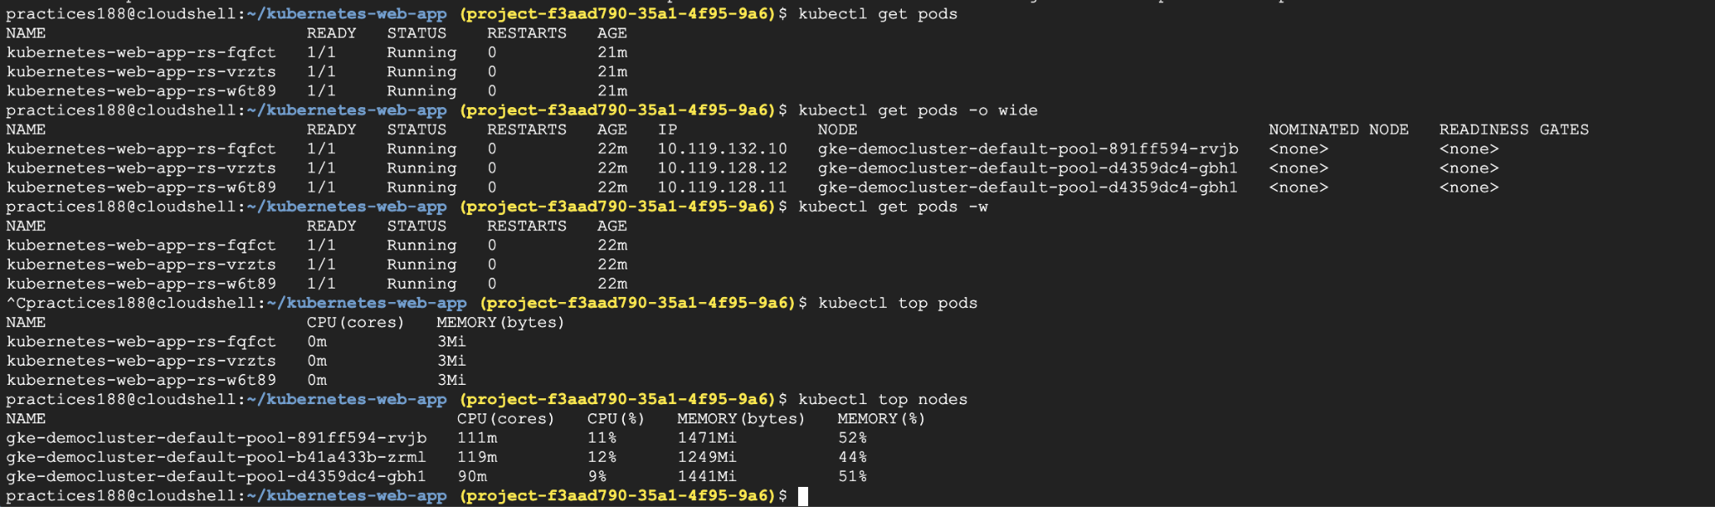
#kubectl get pods
#kubectl logs <pod-name>
#kubectl logs -f <pod-name> →live logs

